

Addis Ababa University

College of Natural and Computational Sciences

School Of Information Science
MSc. In Information Science and Systems (Information Science)
A Project On:
Comparison of Different Machine Learning Algorithms for the Prediction of Cardiovascular Disease

Module: Applied Machine Learning: InSS 660

Submitted by:
SELAHADIN NURGA - GSE/7245/13

Submitted to: Michael Melese (Ph.D.)
February: 2022

Introduction
Machine learning provides the computer to learn without being programmed explicitly. Its focus is on the development and designing of computer programs that can access the data and make use of it to learn themselves. Now a day’s people make use of various machine learning algorithms. Machine learning approaches have been used for classification as an alternative to statistical methods because of their high degree of accuracy. Data mining incorporates statistics, management of databases, machine learning, and areas that aim to extract knowledge from vast volumes of data. Parts of data mining are discovery, model building and testing or validation. For the principle of machine learning, which is the same as the function of the human brain, critical reasoning measures that are required to make decisions are taken into account.
Generally, the method of processing data from multiple viewpoints and summarizing it into usable information is data mining. It helps users to analyze, categorize, and summarize the relationships associated with data from several different dimensions. Data Mining and Machine Learning are Siamese twins from which several insights can be derived through proper learning algorithms. There has been tremendous progress in data mining and machine learning as a result of evolution of smart and Nano technology which brought about curiosity in finding hidden patterns in data to derive value. The fusion of statistics, machine learning, information theory, and computing has created a solid science, with a firm mathematical base, and with very powerful tools. Supervised machine learning algorithms have been a dominant method in the data mining field. Classification is an important technique which helps in machine learning to categorize knowledge of different kinds. Classification is used to classify each object in a data set into a predefined set of classes. Medical professionals need a reliable prediction methodology. There is a vast amount of data about patients and their medical conditions. Disease prediction using health data has recently shown a potential application area for these methods. The main objective of this project is to demonstrate the comparison between different classification algorithms using Python by extracting information from a dataset and turn it into understandable data. This objective is used to propose a technique that can create best Machine Learning algorithm for prediction of cardiovascular disease In the case of Medication It plays a critical role in helping doctors finding successful therapies and delivering g more and more accessible health care to patients.

LITERATURE SURVEY
In 2018, the research studied by [1] ,has considered Seven different machine learning algorithms using Diabetes data set which was made available online at University of California, Irvive website. The algorithms were Decision Table, Random Forest (RF) , Naïve Bayes (NB) , Support Vector Machine (SVM), Neural Networks (Perceptron), JRip and Decision Tree (J48) using Waikato Environment for Knowledge Analysis (WEKA)machine learning too. To implement the algorithms a diabetes data set with 786 instances was used with eight attributes as independent variable and one as dependent variable for the analysis. According to their author’s research, the results show that SVM was found to be the algorithm with most precision and accuracy. Naïve Bayes and Random Forest classification algorithms were found to be the next accurate after SVM accordingly [1].
In 2019 the authors Shahadat Uddin1* , Arif Khan1,2[2] studied a survey on “Comparing different supervised machine learning algorithms for disease prediction”. They selected 48 articles in total for the comparison among variants supervised machine learning algorithms for disease prediction. Based on the survey, they found that the Support Vector Machine (SVM) algorithm is applied most frequently (in 29 studies) followed by the Naïve Bayes algorithm (in 23 studies). However, the Random Forest (RF) algorithm showed superior accuracy comparatively. Of the 17 studies where it was applied, RF showed the highest accuracy in 9 of them. This was followed by SVM which topped in 41% of the studies it was considered [2].
The authors Alexandru Niculescu-Mizil [3] studied his research on “An Empirical Comparison of Supervised Learning Algorithms” in 2006 by using variety of performance criteria to evaluate the learning methods. Their study presents a results of a large-scale empirical comparison of ten supervised learning algorithms with eight performance criteria. They evaluate the performance of the machine learning algorithms like SVMs, neural nets, logistic regression, naive Bayes, memory-based learning, random forests, decision trees, bagged trees, boosted trees, and boosted stumps. The author’s used eleven binary classification problems using a performance metrics. The metrics were accuracy, F-score, Lift, ROC Area, average precision, precision/recall break-even point, squared error, and cross-entropy. The result of their study shows that a learning methods such as boosting, random
Forests, bagging, and SVMs achieve excellent performance that would have been difficult to obtain before. Of the earlier learning methods, feedforward neural nets have the best performance and are
Competitive with some of the newer methods.

Data Collection Method
For this project thanks to kaggle, we have collected the Cardiovascular Disease data set from the kaggle Machine Learning Repository. kaggle contains a collection of data sets that are widely used by the Machine Learning community. From this kaggle repository, the information about Cardiovascular Disease data set and other relevant information are also provided in detail. We have considered 13 attributes of cardiovascular data set with 70,000 instance in the data set and this set having 34979 yes (having cardiovascular disease) cases and 35021 no cases (not having cardiovascular disease).
Description of the Dataset
The dataset that we have collected from the kaggle has a total of 13 columns or features with 70,000 rows or instance. All of the dataset values were collected at the moment of medical examination. According to the description described in the repository, there are 3 types of input features:
- Objective: factual information;
- Examination: results of medical examination;
- Subjective: information given by the patient.
Features:
- Age | Objective Feature | age | int (days)
- Height | Objective Feature | height | int (cm) |
- Weight | Objective Feature | weight | float (kg) |
- Gender | Objective Feature | gender | categorical code |
- Systolic blood pressure | Examination Feature | ap_hi | int |
- Diastolic blood pressure | Examination Feature | ap_lo | int |
- Cholesterol | Examination Feature | cholesterol | 1: normal, 2: above normal, 3: well above normal |
- Glucose | Examination Feature | gluc | 1: normal, 2: above normal, 3: well above normal |
- Smoking | Subjective Feature | smoke | binary |
- Alcohol intake | Subjective Feature | alco | binary |
- Physical activity | Subjective Feature | active | binary |
- Presence or absence of cardiovascular disease | Target Variable | cardio | binary |

Design of the Experiment
For our experiment, basically we have used a total of four steps which will be followed to carry out the research. The first step involves the Exploratory Data Analysis followed by data pre-processing. After applying the data processing technique, the data set is divided or splitted into training and test sets on which the Algorithms will be implemented and finally the Algorithms will be evaluated in the final step
Exploratory Data Analysis
We have used this step in order to gain useful insights into the collected data set through data visualisations and results from performing analysis. This step will help to find if the data set has any missing values, the dimension, identify the Categorical features, numerical features and more.
Data Pre-Processing
Since most of the time, data are not found in the way and shape that we required for the purpose of the optimal performance of learning Algorithms. As a result of this data pre-processing step is the most important step applied by data scientists for applying in Machine Learning Applications.
In our data set we mapped the examination feature like “cholesterol” and “glucose” with assigned values and apply categorical features encoding (changing categorical features into numeric). And then we simply use scikit-learn libraries to divide the dataset into training and test sets.
Forming Features and Target Matrices
The matrix of features to be used as input variables and the target variable will be taken. The input variable features and the target matrices will be taken into X and y variables.
Partitioning the Dataset
During this part of the Pre-processing step, the matrix of features X and the target variable y is splited using the “test_train_split” method of “model_selection” class of scikit-learn. We have used train_size=0.8 or 80% for training and the remainder will be used for Testing the Machine Learning Models that will be implemented in this research. The training and test set of X will be stored into variables called “xtrain_data” and “xtest_data”. Similarly, the y training and test set will be stored in variables “ytrain_data” and “test_data” respectively.
Machine Learning Algorithms
There are various Supervised Machine Learning Algorithms such as K-Nearest Neighbours, Decision Tree, Naive Bayes, Support Vector Machine and boosting algorithms like AdaBoost, Gradient Boosting and “bagging” algorithms like random forest. In this project, we have implemented the following algorithms and compare them with different metrics measurements. The algorithms that we have implemented were Logistic regression, RandomForest, KNN and Decision tree Naïve Bayes classifier.
Decision Tree
Decision Trees (DT) are trees that classify instances by sorting them based on feature values. Each node in a decision tree represents a feature in an instance to be classified, and each branch represents a value that the node can assume. Instances are classified starting at the root node and sorted based on their feature values
Decision tree learning, used in data mining and machine learning, uses a decision tree as a predictive model which maps observations about an item to conclusions about the item's target value. More descriptive names for such tree models are classification trees or regression trees [20].Decision tree classifiers usually employ post-pruning techniques that evaluate the performance of decision trees, as they are pruned by using a validation set. Any node can be removed and assigned the most common class of the training instances that are sorted to it [2].
Logistic regression
This algorithm (Logistic regression) is supervised classification algorithm with a powerful and well-established method. Many researchers has considered logistic regression as an extension of ordinary regression and can be used to model binary variable which usually represents the occurrence or non-occurrence of an event. Logistic regression helps in finding the probability that a new instance belongs to a certain class. Since it is a probability, the outcome lies between 0 and 1. Therefore, to use the LR as a binary classifier, a threshold needs to be assigned to differentiate two classes [2].
Random forest
Random forest is one of a group of Supervised Machine Learning Algorithm that is used widely in both Classification and Regression problems. The algorithm builds many decision trees on different samples and takes their majority vote for classification and average in case of regression.
One of the most important features of the Random Forest Algorithm is that it can handle the data set containing continuous variables as in the case of regression and categorical variables as in the case of classification. It performs better results for classification problems. The algorithm uses Ensemble techniques which simply means combining multiple models. Thus a collection of models is used to make predictions rather than an individual model. The ensemble technique is bagging. Bagging creates a different training subset from sample training data with replacement & the final output is based on majority voting [4].
K-Nearest Neighbour Algorithm
K-closest neighbors (KNN) algorithm is a kind of supervised machine learning algorithms which can be utilized for both classification as well as regression predictive issues. KNN is a lazy learning algorithm since it doesn't have a specific training phase and uses all the data for training while classification. Additionally, KNN is a non-parametric learning algorithm calculation since it doesn't expect anything about the fundamental data. K-closest neighbors (KNN) calculation utilizes 'highlight closeness' to anticipate the estimations of new data points which further implies that the new data point will be assigned a value based on how closely it matches the points in the training set[1].

Naive Bayes
Naive Bayes is a classification algorithm for binary (two-class) and multiclass classification problems. It is called Naive Bayes or idiot Bayes because the calculations of the probabilities for each class are simplified to make their calculations tractable. Rather than attempting to calculate the probabilities of each attribute value, they are assumed to be conditionally independent given the class value. This is a very strong assumption that is most unlikely in real data, i.e. that the attributes do not interact. Nevertheless, the approach performs surprisingly well on data where this assumption does not hold [4].
Performance Evaluation Methods used
The performance evaluation of various machine learning algorithms like correctly classified instances, incorrectly classified instances are to be discussed. We are about to do calculation of True positive rate, False positive rate Precision, Recall, F-Measure and confusion matrix of various considered machine learning algorithms.
Confusion Matrix
It is an evaluation metric which is used to describe the performance of a classifier by calculating evaluation parameters. Confusion Matrix helps us to visualize the point where our model gets confused in discriminating two classes. It can be understood well through a 2×2 matrix where the row represents the actual truth labels, and the column represents the predicted labels.
Where TP = True Positive i.e. positive instances that are classified as actual and correct prediction of CAD, FP = False Positive i.e. negative instances that are classified as positive, FN = False Negative i.e. positive instances that are classified as negative, TN = True Negative i.e. negative instances that are classified as negative. The values of the true positive rate and false positive rate are generated using a confusion matrix [5].
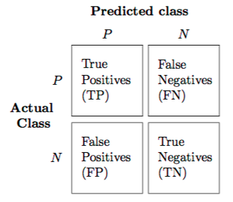
This matrix consists of 4 main elements that show different metrics to count a number of correct and incorrect predictions. Each element has two words either as follows:
- True or False
- Positive or Negative
If the predicted and truth labels match, then the prediction is said to be correct, but when the predicted and truth labels are mismatched, then the prediction is said to be incorrect. Further, positive and negative represents the predicted labels in the matrix.
Accuracy
In this project we have also used Accuracy as one of the method of performance evaluation for the different supervised classification algorithms comparison given by Equation:
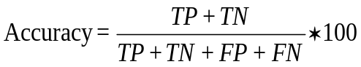
Precision
Precision is defined as the ratio of correctly classified positive samples (True Positive) to a total number of classified positive samples (either correctly or incorrectly). Precision helps us to visualize the reliability of the machine learning model in classifying the model as positive.
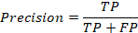
Recall
The recall is calculated as the ratio between the numbers of Positive samples correctly classified as Positive to the total number of Positive samples. The recall measures the model's ability to detect positive samples. The higher the recall, the more positive samples detected.
F-score
The F-score, also called the F1-score, is a measure of a model’s accuracy on a dataset. It is used to evaluate binary classification systems, which classify examples into ‘positive’ or ‘negative’.
The F-score is a way of combining the precision and recall of the model, and it is defined as the harmonic mean of the model’s precision and recall.
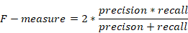

Results Analysis
Results of Exploratory Data Analysis
Figure 1 shows the results of running the code for obtaining the descriptive statistics of the imported dataset to python. It is seen that the dataset contains a total of 70,000 rows and 13 columns with column names of “id” to “cardio”. The data-types include 7 floats and 6 integers. It is shows that also the dataset contain a missing values with a feature name height, weight, ap_lo, cholesterol, gluc, smoke and alco.
Figure 1: Descriptive statistics
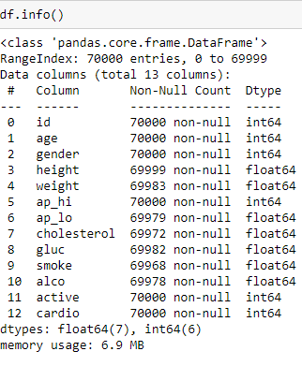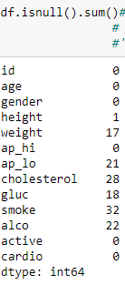
Results of Data Pre-Processing
At the first stage, the raw dataset features like 'cholesterol', 'gluc', 'gender' is processed into another form by converting all the categorical variables into dummy variables and to avoid the dummy variable trap the last columns were dropped.
We also run a code to find and visualize the relationship between cardio vascular diseases with respect to the age of a person. As we can see on the figure_2, According to the dataset we have, we can say that as the age of a person increase, the probability of having the cardio vascular disease also increase.
Figure 2: The Relationship between Age vs Cardio
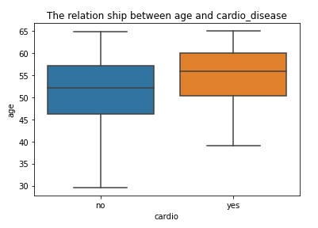
When we try to visualize the distribution of the feature “age” in figure 3 using histogram, they are not normally distributed or it seems the tail is on the left side. This means that the mean is typically less than the median; the tail of the distribution is longer on the left hand side than on the right hand side; and. the median is closer to the third quartile than to the first quartile.
Figure 3: Age distribution histogram
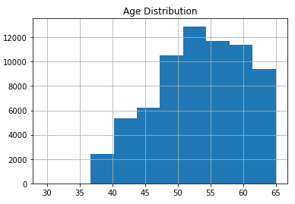

Figure 4: Descriptive statistics
The line of code (df.describe ()) below prints the mean of the numerical variables in the data. From the output, we can infer that the average age of the dataset is 53 years, the average height is 164, the average weight 74kg and so on. As we described above, the that the mean is typically less than the median for the feature age and height
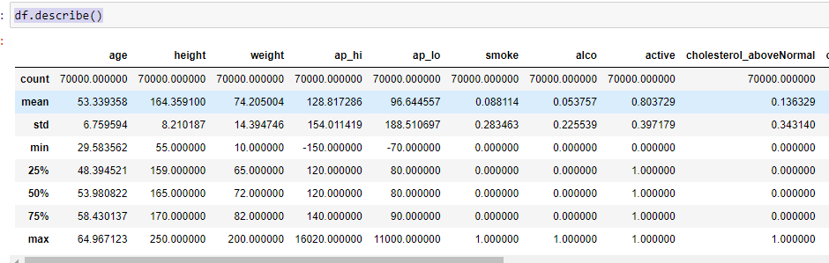

Results of Model Evaluation
Logistic Regression
Logistic Regression is implemented on the processed data with balanced classes of No=35021 and Yes =34979. From Figure 5 the Confusion Matrix of the model shows that it has returned with TP = 4686 and TN = 5297 and an accuracy score of the accuracy is 0.713%. When we look the accuracy measure of precision, Recall and F_measure we got the following.

=

=

Figure 5: logistic regression confusion matrix
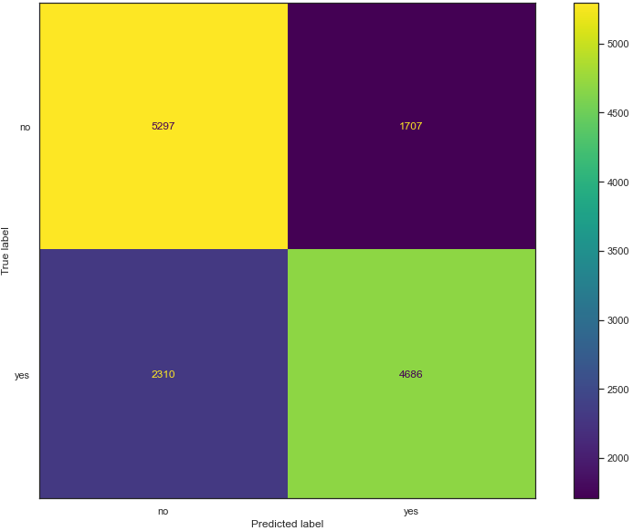

Random forest
We have also is implemented a RandomForest algorithm on the processed data with balanced classe of No=35021 and Yes =34979. From Figure 5 the Confusion Matrix of the model shows that it has returned with TP = 4661 and TN = 5580. The highest accuracy score from the Confusion Matrix is found when the Random forest is trained on the balanced target classes with the model being 73%. When we look the accuracy measure of precision, Recall and F_measure we have got the following results.
=

=

=

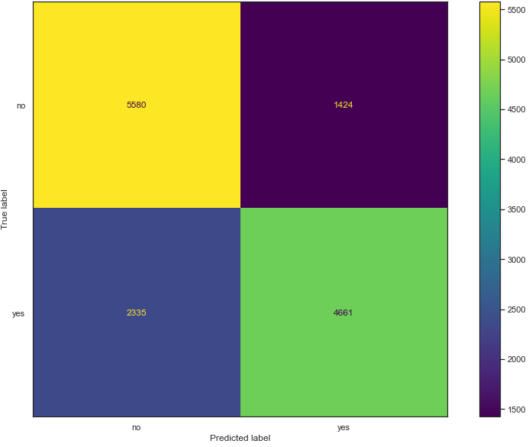
Figure 6: Random forest classification confusion matrix
K-nearest neighbors algorithm

The results show that our KNN algorithm was able to classify the records in the test set with 72% accuracy. The result of the KNN algorithm is nearly similar to Random Forest algorithm implementation result. The confusion matrix of this algorithm is shown on the figure 7.
=

=

=

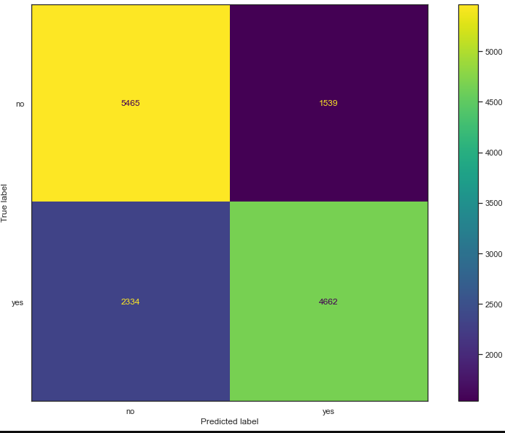
Figure 7: KNN algorithm confusion matrix

Naive Bayes classifiers
By implementing Naïve Bayes classifier algorithm for our dataset, we have got that our model accuracy score is 0.60. Based on a confusion matrix which enables us for summarizing the performance of a classification algorithm we have the following result.

=

=

=

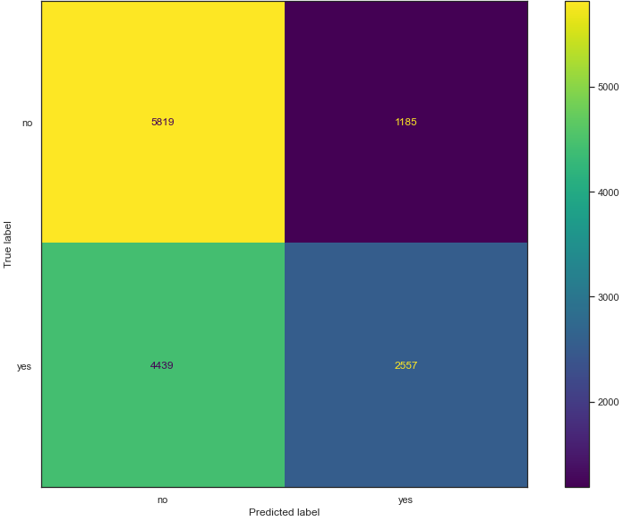
Figure 8: Naive Bayes classifiers confusion matrix
Decision Trees
In our experimental implementation, we have also used a Decision Tree algorithm and trained the algorithm and made some predictions. Based on the result we get, the algorithm accuracy scores 73% which is good. From the confusion matrix, you can see that out of 14,000 test instances, our algorithm misclassified 3742. Not too bad!
=

=

=

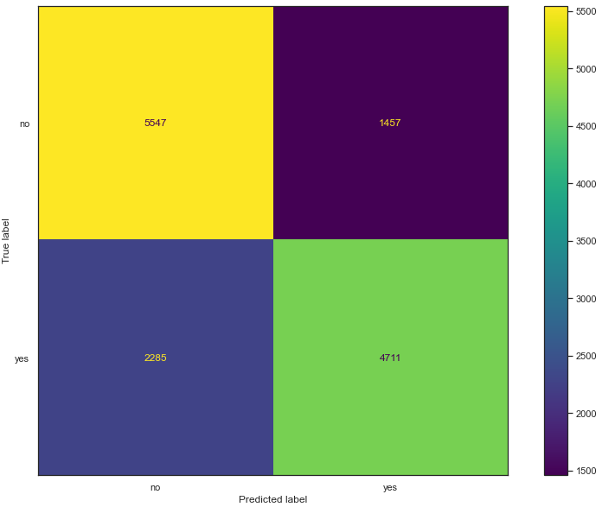
Figure 9: Decision Trees classifier confusion matrix
Generally on the implementation of the five supervised machine learning algorithms, we have got the following summarized result for the cardio vascular dataset
Table 1: Comparison of various classification algorithms
Algorithm | Time | Correctly  Classified  (%) | Incorrectly  Classified  (%) | Attributes | Precision of YES | Precision of NO | Recall of YES | Recall NO
Random Forest | 1.08s | 0.73 | 0.27 | 16 | 0.77 | 0.70 | 0.77 | 0.80
Decision Tree | 276ms | 0.73 | 0.27 | 16 | 0.76 | 0.71 | 0.67 | 0.79
K Nearest Neighbor (KNN) | 79.1ms | 0.72 | 0.28 | 16 | 0.75 | 0.70 | 0.67 | 0.78
logistic regression | 477ms | 0.71 | 0.29 | 16 | 0.73 | 0.70 | 0.76 | 0.67
Naive Bayes | 118ms | 0.60 | 0.40 | 16 | 0.68 | 0.57 | 0.37 | 0.83

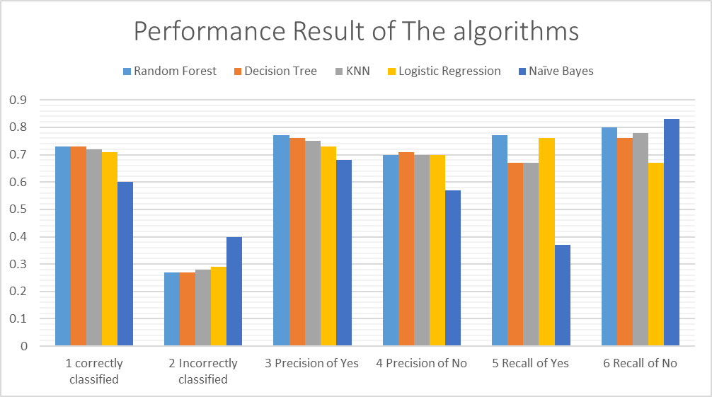

DISCUSSION AND RESULTS

In this assessment project, we applied supervised Machine Learning Algorithms on cardiovascular dataset to predict patients who have a cardiovascular and who do not. Our objective was to propose a technique that can create best Machine Learning algorithm for prediction of cardiovascular disease. Our examination was made based on five calculations positioned among the Decision Tree, K-Nearest Neighbor, Logistic Regression, Naive Bayes and Random Forest. From the tables 1, we have the following results from the five stated comparison algorithms.

According to the accuracy score of the algorithms, both RandomForest and Decision tree algorithm has scored the same values followed by K-Nearest Neighbor algorithm (KNN), logistic regression and Naïve Bayes classifiers respectively. RandomForest and Decision tree algorithm has Correctly Classified the instances 73% and nearly 27 % of the instance has Incorrectly Classified. Among the five supervised algorithms, Naive Bayes classifiers has scored a minimum value which classifies only 59% of the instance correctly and 41% of the instance are incorrectly classified which is bad. Random forests are not good based on the running time relative to the other algorithms and K Nearest Neighbor (KNN) is the one which takes the least time than all other algorithms.

Conclusion
This project attempted to study comparative performances of different supervised machine learning algorithms in cardiovascular disease prediction performance. A detection of cardio vascular Disease is built using Random forest, Decision Tree, Logistic Regression, K-Nearest Neighbor algorithm (KNN) and Naïve Bayes classifiers. After performing Statistical Analysis on the data set, it was found that some of the dataset contain a missing values. From the Exploratory Data Analysist there is a class balance in the dataset as patients with cardio disease are nearly the same as Normal. Then before implementing the model pre-processing steps were carried out. Various performance matrices were used like precision, Recall, F-score and accuracy. Results show that the performance of Decision Tree and Random Forest has scored better than the rest of the three algorithms. Overall, Decision Tree and Random Forest algorithms had the highest average accuracy of 73%.

Reference
[1] O. F.Y, A. J.E.T, A. O, H. J. O, O. O, and A. J, “Supervised Machine Learning Algorithms: Classification and Comparison,” Int. J. Comput. Trends Technol., vol. 48, no. 3, pp. 128–138, 2017, doi: 10.14445/22312803/ijctt-v48p126.
[2] S. Uddin, A. Khan, E. Hossain, and M. A. Moni, “Comparing different supervised machine learning algorithms for disease prediction,” vol. 8, pp. 1–16, 2019.
[3] R. Caruana, “An Empirical Comparison of Supervised Learning Algorithms,” pp. 161–168, 2006.
[4] M. Srivenkatesh, “Prediction of Cardiovascular Disease using Machine Learning Algorithms,” Int. J. Eng. Adv. Technol., vol. 9, no. 3, pp. 2404–2414, 2020, doi: 10.35940/ijeat.b3986.029320.
[5] “Confusion Matrix No More Confusing.” https://laptrinhx.com/confusion-matrix-no-more-confusing-4257385063/ (accessed Oct. 02, 2022).

